Part 1: Zero-Knowledge Proof (ZKP) Simulation Tools: Python 1. Simulate the Ali Baba Cave protocol using Python. Have the user (Alice) randomly select a path and respond to the verifier's (Bob’s) random challenge.
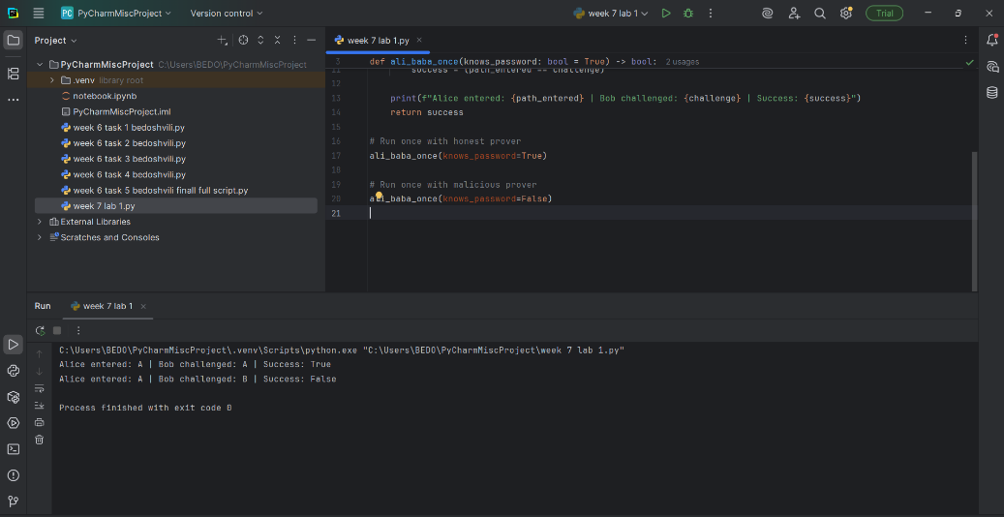

2. Repeat the simulation 20 times. Track how many times a prover without the password would succeed by guessing. Task: Modify the simulation to calculate success probability for a malicious prover.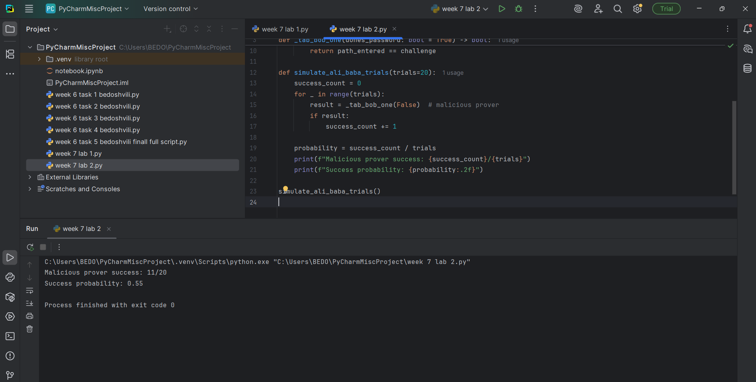

Part 2: Code Obfuscation Challenge Tools: Python Or any Programming language
1. Create a simple function (e.g., factorial or Fibonacci).
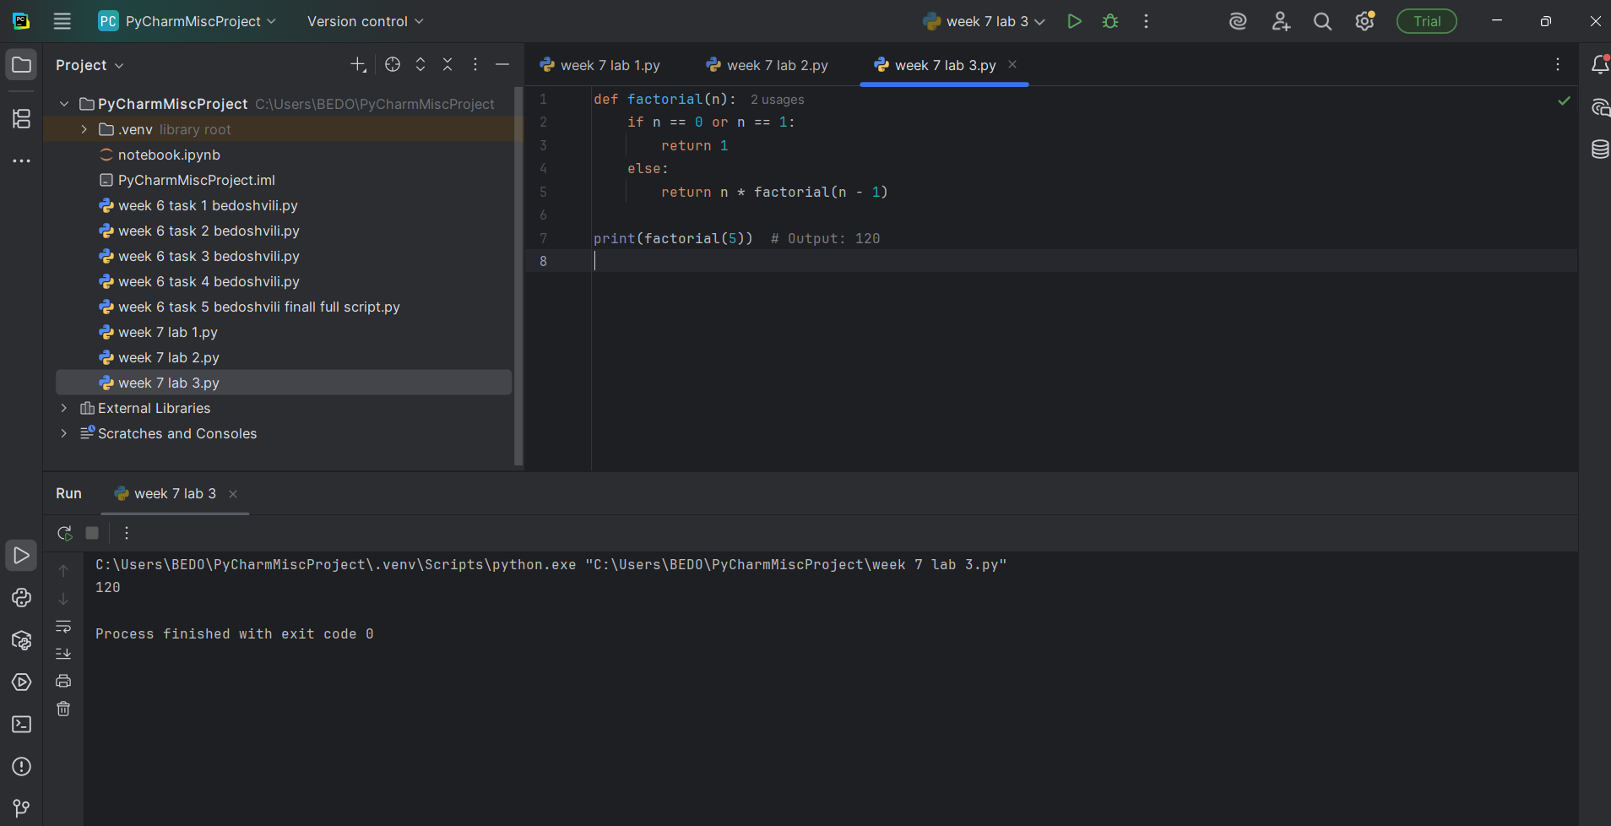
2. Apply manual obfuscation: Rename variables to meaningless values.
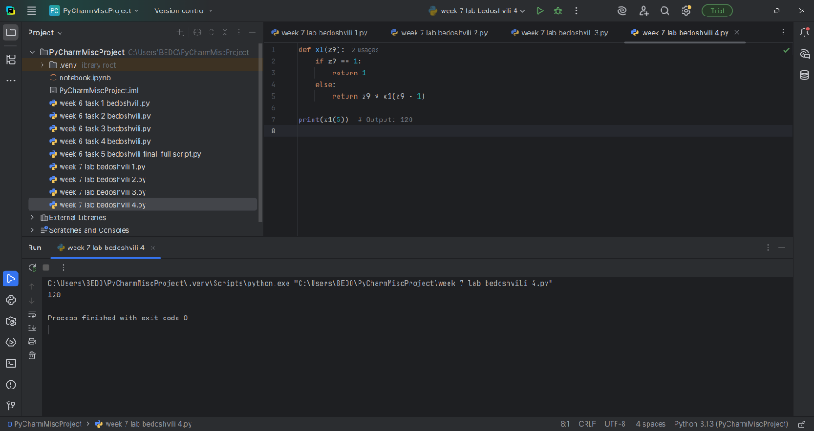
Manual obfuscation was applied by renaming the function and variable names to meaningless identifiers. The original function `factorial(n)` was changed to `x1(z9)` to make the code harder to interpret, while preserving its functionality. This technique helps prevent reverse engineering and casual code analysis.

3. Apply automatic obfuscation use any tool
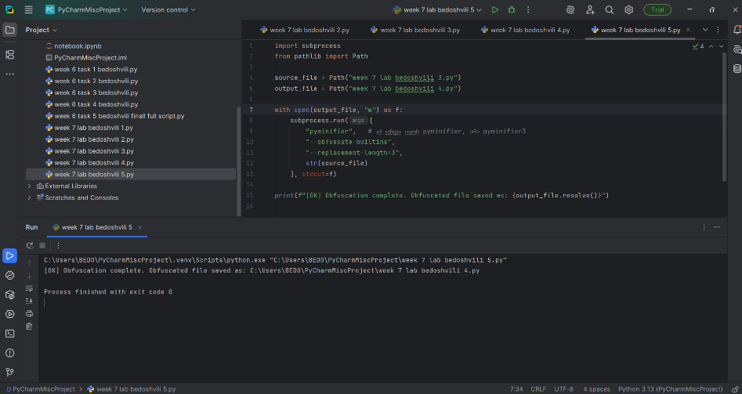
The obfuscation process was successfully completed. The script 'week 7 lab bedoshvili 5.py' was executed to obfuscate the original factorial file 'week 7 lab bedoshvili 3.py'. The resulting protected version was saved as 'week 7 lab bedoshvili 4.py'. Process finished with exit code 0, confirming successful execution.

4. Share both original and obfuscated code.
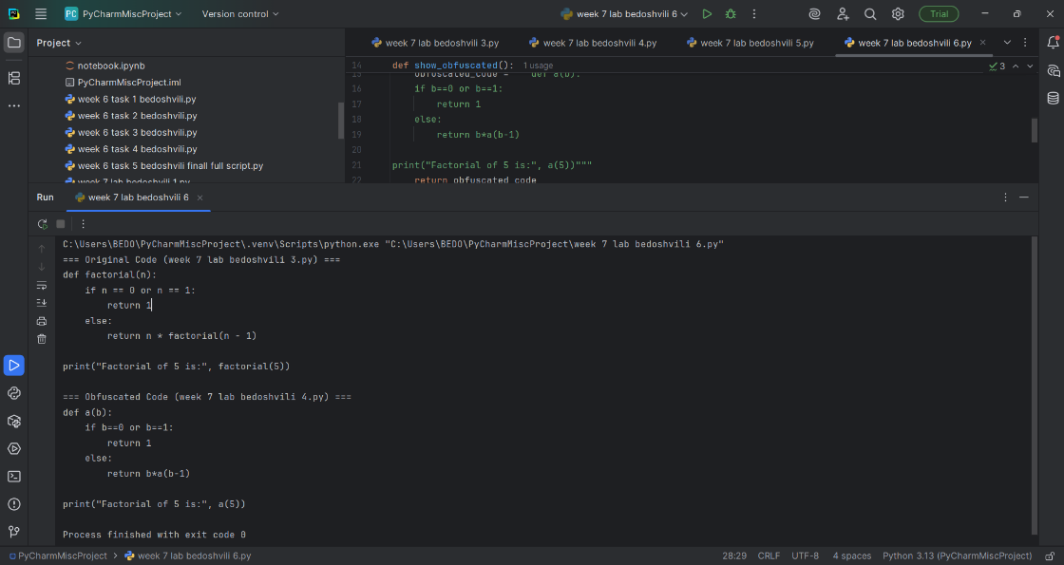
The script 'week 7 lab bedoshvili 6.py' was executed to print both versions. The original factorial function was implemented in 'week 7 lab bedoshvili 3.py'. The obfuscated version was generated and saved in 'week 7 lab bedoshvili 4.py'. Running 'week 7 lab bedoshvili 6.py' displayed both codes successfully, and the process finished with exit code 0, confirming correct execution.

Task: Explain what type of obfuscation you used and why.
The obfuscation method applied in this assignment was automatic identifier renaming using the Pyminifier3 tool. This technique systematically replaced meaningful function and variable names with short, meaningless symbols (for example, the original function factorial(n) was transformed into a(b)). As a result, the logical structure of the program became significantly harder to interpret for a human reader, while the underlying functionality remained unchanged.
The rationale for using this type of obfuscation is threefold:
- Simplicity and reproducibility – Identifier renaming is one of the most straightforward obfuscation techniques. It can be consistently applied across different scripts without requiring manual intervention, making it ideal for academic demonstration and reproducible experiments.
- Protection against reverse engineering – By obscuring meaningful names, the code becomes resistant to casual inspection or unauthorized modification. This directly supports the core purpose of obfuscation: protecting intellectual property and preventing easy comprehension of the source code.
- Balance between security and usability – Unlike heavier obfuscation methods (such as control flow flattening or string encryption), identifier renaming does not break the program’s functionality or introduce runtime overhead. It provides a practical balance between making the code less human-readable and keeping it fully executable.
Conclusion: The obfuscation type used was automatic identifier renaming via Pyminifier3. This approach was chosen because it effectively demonstrates how code can be made less human-readable while preserving its functionality. It achieves a balance between protection and usability, making it suitable for academic exercises in software security and code protection.

